Objective Questions for chapter 5
- A Mealy machine consists of the following, except :
  - A finite set of states q₀, q₁, q₂, … where q₀ is the initial state.
  - An alphabet of letters Σ = {a,b,c,…} from which the input strings are formed.
  - An alphabet Ѓ={x,y,z,…} of output characters from which output strings are generated.
  - An output table that shows what character is printed by each state as it is entered.

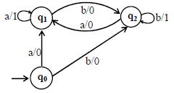
if in the output string the nth character is 1, input string the machine will print
a) 0000100010
b) 0001011000
c) 0000100001
d) 0000100011

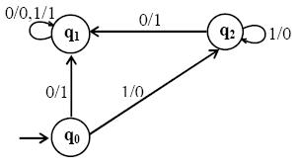
If the strings 100101110 and 1001100111 are run over this machine, the corresponding output strings will be
a) 100101111 and 1001101000
b) 100101111 and 1001101110
c) 100100111 and 1001101001
d) 100100011 and 1001101000

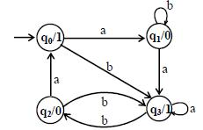

If the string abbabbba running over the above machine, the corresponding output string will be :
a) 100010101
b) 100010111
c) 110010101
d) 100010100

- 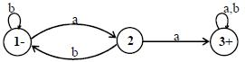
It may be observed that the FA* accepts only the additional string which is :
a) Null String
b) 1 string
c) 10 string
d) All answer is correct

- Let L be the language of strings, defined over Σ = {0,1}, ending in 01. for 1 belonging to Σ* s.t. both 1111 and 010011 don’t belong to L, which string is indistinguishable :
a) 111 and 010011
b) 111 and 010111
c) 100 and 010011
d) 101 and 011011

- A Moore machine consists of the following, except :
a) A finite set of states q₀, q₁, q₂, … where q₁ is the initial state.
b) An alphabet of letters = {a,b,c,…} from which the input strings are formed.
c) An alphabet Σ={x,y,z,…} of output characters from which output strings are generated.
d) A transition table that shows for each state and each input letter what state is entered the next.

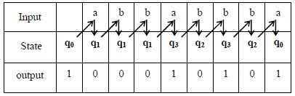

It may be noted that the length of output string is l more than that of input string as the initial state prints out the extra character which is :
a) 1
b) 0
c) Null
d) All answers is wrong.

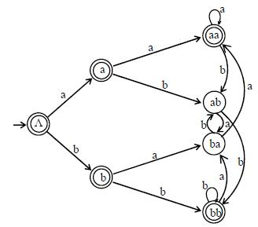
How many number of states required to recognize the language :
a) 12
b) 11
c) 15
d) 17

- Let L be the language of strings, defined over Σ = {0,1}, ending in 01, which string is distinguishable :
  - 110 and 010011
  - 101 and 001001
  - 110 and 100011
  - 101 and 010011

